Programming NAO - Cheat Sheet

**Connecting to the robot**

Klick on the green “Wireless connection” symbol on top. In the Window that comes up, either click on the local robot (the blue one with dotted lines) for a simulation, or the green or red NAO for the real NAO. Sometimes it might warn you that the robot seems unresponsive and ask if you want to connect anyway – just click yes and it will connect.

**Start a module**

Simply click on the module in the left lower corner of the window and drag and drop it to the main window. Then draw a line from the little start symbol on the top left corner of your programming window to the incoming arrow of your box and another line from the outgoing arrow of your box to the top right finish symbol of your programming view. It should look like this:

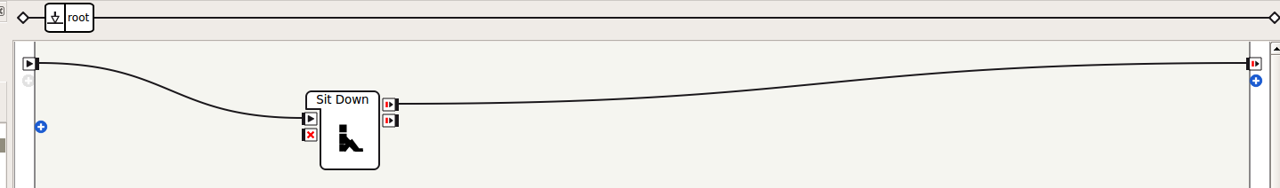

To start your program, just click on the green start button next to the wireless connection symbol on top menu bar.

**Configure a module**

There are three different types of configurations:

1. If the box has a little screw-wrench in its bottom left corner. You can click on it and a small window will open. In this window, you can set different parameters, like the distance the robot should walk or which LEDs to change.
2. If you double-click on the box, the box might split into two boxes – one box looks like the original one, the other is a configuration box. This is an example:

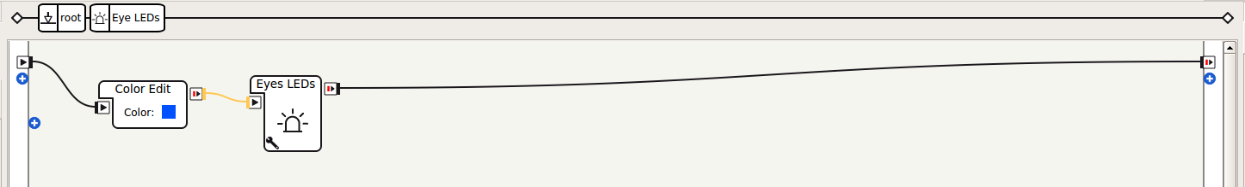The left box is the configuration box. Here you can edit certain features, like the color of the LEDs. Important: The original box has not really been split. If you look above the boxes, you will notice that another small box has appeared to the right of the *root box*. That means you are in a sub-view of a certain box. In this view you can configure the box, but you cannot let the program run on the robot. So once you are done configuring the module, click on the little *root box* to change the view again and run the program.

1. If you double-click on the box, it might also open another window where you can change the source code of the box. Just change the source code in the editor and then close it again. You don't need to save anything, it will be saved automatically. If there is an error in your source code, it will show you a red error message in the *log viewer* to the bottom of your Choregraphe window when you try to run it.

**Writing a dialog with the NAO**

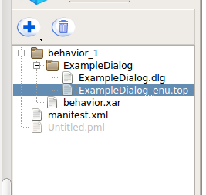As we are representing the social robotics lab, writing a little dialog is a nice example for older kids. Just drag and drop the *Dialog box* from the Voice folder to the main programming field. You will also need the *Set Language box*. Select it and place it in front of the *Dialog box*. Now connect the start symbol with the *Set Language*, the *Set Language* with the *Dialog* and the *Dialog* with the finish symbol.

To edit the dialog, you need to open the *ExampleDialog_enu.top* file which you can find to the left. Double-click on it to open the editor.

The first thing you see is the definition of concepts. A concept means you define a concept name and then a variety of different options to say which represents the same concept. If an option consist of multiple words, they must start and end with quotation marks. Concepts can be used in the dialog in two different ways: They can either represent some input given by the human user or different options for the robot to respond (it will select one randomly).

Inside the dialog, the NAO can either react to what the human said or can make it's own proposal.

With this line here the NAO will react to a user's input:

If the users says one of the phrases defined in the concept *hello*, it plays an animations, responds with a phrase from the concept *hello* and waits until the animation has finished playing. Then it proceeds to a proposal:

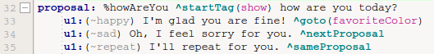The proposal starts with a *%* followed by the name of the proposal. It is used to call the proposal from somewhere else in the script. A *tag* is only a set of different animations from which the robot will randomly pick one. You find a list of tags and animations you can use attached. It then asks a question and awaits one of the three answers the user can give. It will respond differently to each answer and then eventually proceed with the next proposal.

After you started the program, the robot will indicate that it is listening with a beep-sound and blue blinking eyes. After you said something, it will either respond in the way it is programmed or – if it did not understand what you said – will beep again to indicate you need to start talking again. Speak loud and clear and close to the robot to increase the chances it understands you. However, in the noisy environment it might be difficult to test it on the real robot. You can always test it with the simulator by typing in the command in the *Dialog view*.

**Demonstration Mode**

There will be a demonstration script for Choregraphe which you can use to show the abilities of the robot and engage them to work with you.

